Name – Arpita Waghmare
PRN-24070521006
Batch-A1
SEC-A
Date of practical – 9 july 2026 Date of submission- 15 july 2026
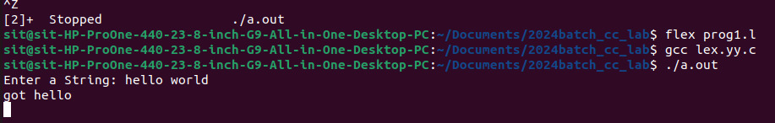

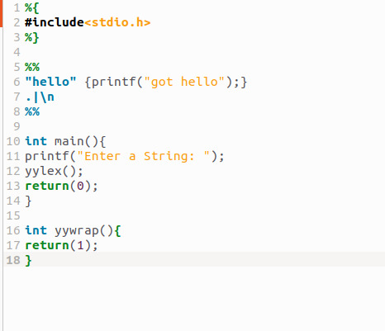

Name – Arpita Waghmare
PRN-24070521006
Batch-A1
SEC-A
Date of practical – 9 july 2026 Date of submission- 15 july 2026



